Intro Questions
Question 1
What is your role in the activity you’d like to assess today?
- Worker
- Supervisor
- Manager
- Employer
- Member of a H&S Committee

Question 2
How long have you been in this role with your current employer?
- Less than a year
- 1 to 5 years
- 6 to 10 years
- More than 10 years

Question 3
What is the task or work activity you'd like to assess? Be as descriptive as possible.
[user text input]

Suggested preprocessing tags generated from question 3 (IDEA)

[
"office_computer",
"desk_based",
"seated_work",
"standing_work",
"walking_moving",
"manual_handling",
"lifting_carrying",
"pushing_pulling",
"heavy_loads",
"tool_use",
"powered_tools",
"vibrating_tools",
"vehicle_equipment",
"kneeling_floor_work",
"sharp_edges",
"body_as_tool",
"gripping",
"pinch_grip",
"power_grip",
"wrist_hand_work",
"repetitive_work",
"reaching_forward",
"overhead_work",
"low_work",
"twisting",
"bending_trunk",
"fine_visual_work",
"screen_work",
"glare_exposure",
"outdoor_work",
"cold_environment",
"noise_exposure",
"tight_deadlines",
"overtime",
"low_task_variability"
]

Question 4
Please indicate your height using the options below:
- Less than 5’4’’ (< 1.62 m)
- 5’4’’ – 5’9’’ (1.62 m – 1.75 m)
- 5’10’’ – 6’2’’ (1.76 m -1.88 m )
- over 6’2’’ (> 1.88 m)
- Prefer not to say

Description
The following questions are about the work you do during a typical workday or when you're completing the specific task or activity you'd like to assess today. The intent is for you to tell ErgoCheck about what you do to get your work done.

Question 5
How would you summarize the type of job or task being assessed?
- Office or clerical (desk-based) job or task
- Not based at a desk in an office
- Both set-ups

Question 6
Do you typically sit or stand during your workday?
- I usually sit for most of the day
- I usually stand or move for most of the day
- I sit and stand throughout the day

Question 7
To what extent would you say your employer or supervisor seeks your feedback on tools or equipment before they're purchased?
- To a great extent
- To some extent
- Rarely
- Not at all

Question 8
To what extent would you say your employer or supervisor seeks your feedback on how the work you do should be organized and/or performed?
- To a great extent
- To some extent
- Rarely
- Not at all

Question 9
In the last 7 days, have you experienced work-related pain or discomfort?
- Yes
- No

Question 10
Using the table below, please indicate the specific body parts where you have experienced work-related pain or discomfort during or after performing the job or task being assessed. Indicate whether a) one or both sides of your body were involved, and b) the pain lasted for 2 or more days.

 | Pain or discomfort on one side (i.e., left or right side of body) | Pain or discomfort on both left and right | Pain has lasted for 2 or more days
Neck
Shoulder(s) or upper arm(s)
Elbow(s) or forearm(s)
Elbow(s) or forearm(s)
Lower back
Hip(s) or upper leg(s) (thigh)
Hip(s) or upper leg(s) (thigh)
Ankle(s) or foot/feet

Contact Stress
The next set of questions explores contact stress you may experience while performing the job, task, or work activity you're assessing today. Contact stress is when a hard or sharp object comes in contact with the skin (e.g., when the edge of a computer desk digs into your wrist).
You may see questions that are not relevant to your job or industry; for these questions, select the answer that lets us know this doesn't apply to you (e.g., "I don't ...").

Question 11
Think about a typical workday - or, if you're assessing a specific task or activity, the part of the workday when you're performing that task. How much time do you spend leaning or resting part of your body on sharp objects or edges?
- Less than 30 minutes a day
- 30 minutes to 1 hour a day
- More than 1 hour a day
- I don't lean on sharp objects or edges at work

Question 12
How much time do you spend kneeling on hard or rough surfaces without personal protection (e.g., without knee pads)?
- Less than 30 minutes a day
- Between 30 minutes to 1 hour a day
- More than 1 hour a day
- I don't kneel on hard surfaces without protection at work

Question 13
Please think about the types of tools or objects you hold for more than 30 minutes at a time. Using the list of descriptions below, select all the statements that apply to these items.
- Too large or small to grip properly
- Shaped irregularly or unbalanced
- Have handholds that are too sharp
- Slippery
- None of the above

Question 14
Do you use any body part as a makeshift tool to complete your work? (For example, you might use your palm or knee to apply force to a surface.)

The illustration below is an example of using your body in this way.
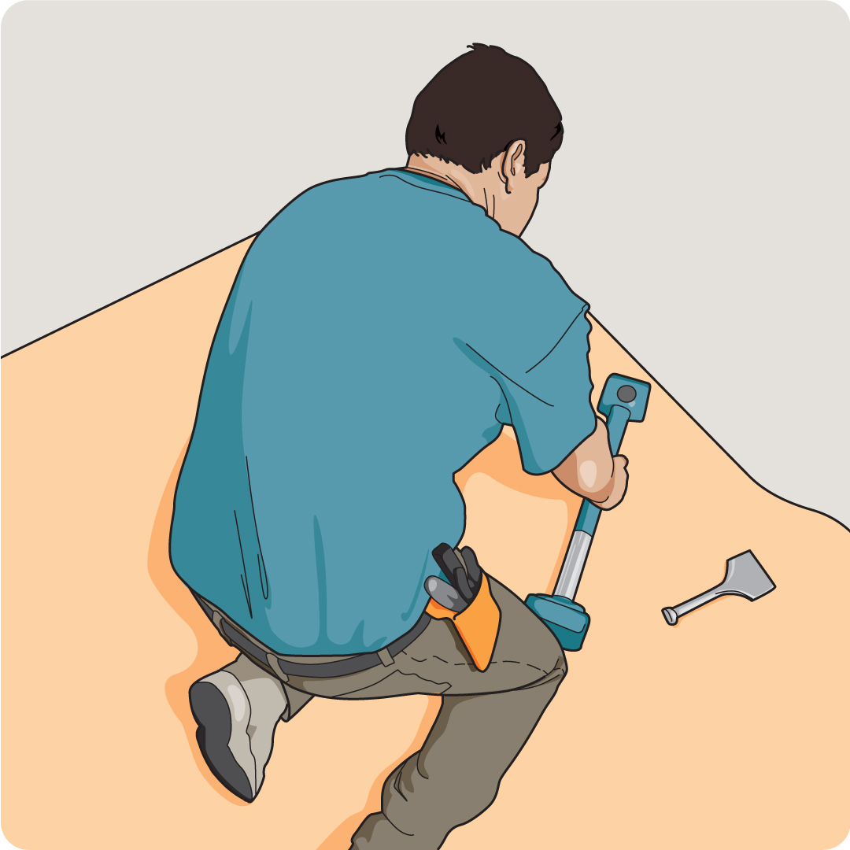
- Yes, for less than 1 hour a day
- Yes, for more than 1 hour a day
- No, I don't use my body as a makeshift tool in my work

Question 15
Think about the types of surfaces you push, pull, or move objects across during the job, task, or work activity you are assessing today. Using the list of descriptions below, select all the statements that apply to these surfaces.
- Smooth (e.g., finished surfaces)
- Soft (e.g., sand, mud, grass)
- Rough (e.g., gravel, tile, granite)
- I don't push or pull objects across any surfaces to complete my work

Question 16
How often do you push, pull, or move objects that you consider to be heavy without a mechanical aid (e.g., a wheelbarrow or dolly)?
- Most of the time
- Some of the time
- Never

Question 17
How heavy are the tools or objects you pick up, carry, or support without mechanical assistance?
Less than 5 lb / 2 kg
- 5 to 18 lb / 2 to 8 kg
- More than 18 lb / 8 kg
- I don't pick up, carry, or support any tools or objects at work

Question 18
Do any of the tools and/or equipment you use require a lot of force to start? (e.g., a lawnmower with a cord you need to yank or a pedal you need to firmly depress)
- Yes, at least some of the tools or equipment I use regularly require force
- Yes, at least some of the tools or equipment I use occasionally require force
- No, none of the tools or equipment I use require force to start

Question 19
When pushing and/or pulling objects that you consider heavy, to what extent do you receive assistance (e.g., from a coworker, by using a dolly or wheelbarrow)?
- To a great extent
- To some extent
- I do not ask for assistance
- I ask for but do not receive assistance
- I don’t push or pull these kinds of objects during the workday

Awkward Postures
The next set of questions will help ErgoCheck identify awkward postures you may hold while performing your work. Ideally, each part of your body should be in a neutral position while you're sitting or standing. An awkward posture involves a body part being bent, extended, twisted, or flexed.
We classify awkward body postures by measuring the angle between the ideal neutral position and the bent or flexed position (in degrees).

Question 20
Think about a typical workday — or, if you’re assessing a specific task or activity, the part of the workday when you’re performing that task. When either sitting or standing, how often do you work with your upper body leaning forward, backward, or sideways?

Please select the options that apply to you.

 | Most of the time | Some of the time | Never
I lean forward or backwards more than 15 degrees
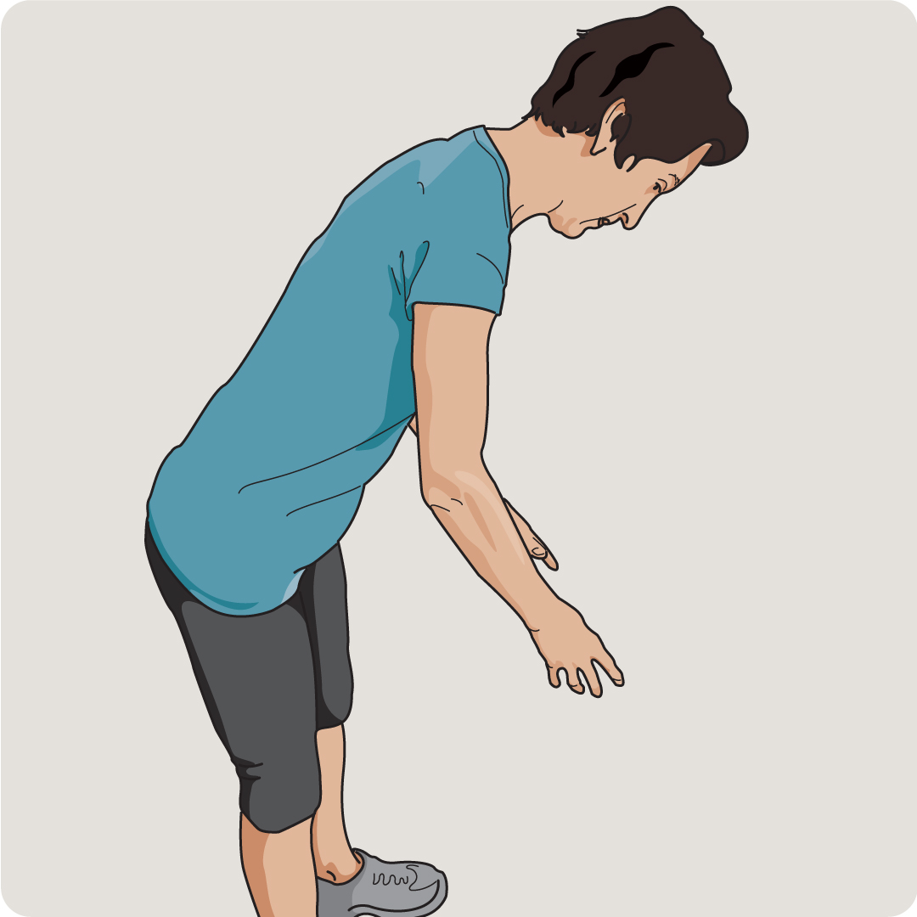
I lean sideways
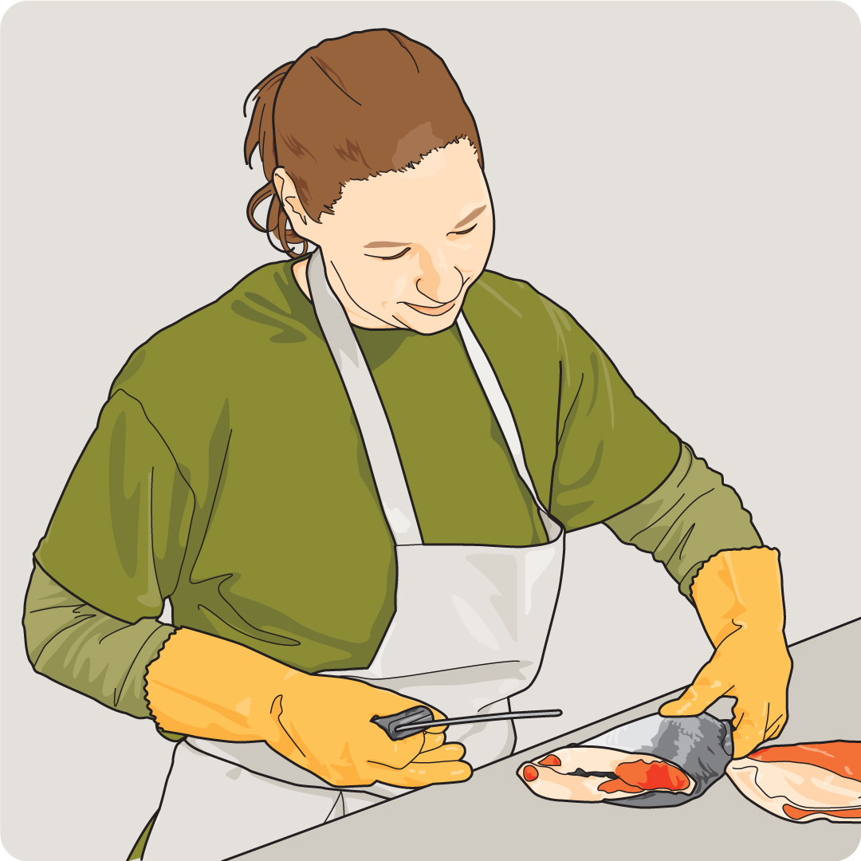

Question 21
When performing your work activities, do you ever twist your upper body to either side without changing the position of your feet while sitting or standing?
- Yes, I do this often during my job, task, or work activity
- Yes, I do this sometimes during my job, task, or work activity
- No, I never twist my upper body when working

Question 22
Thinking about a typical workday – or, if you’re assessing a specific task or activity, the part of the workday when you’re performing that task. When either sitting or standing, please indicate where your hands are located in relation to your body.

Please select the options that apply to you.

 | Most of the time | Some of the time | Never
Hands above shoulders
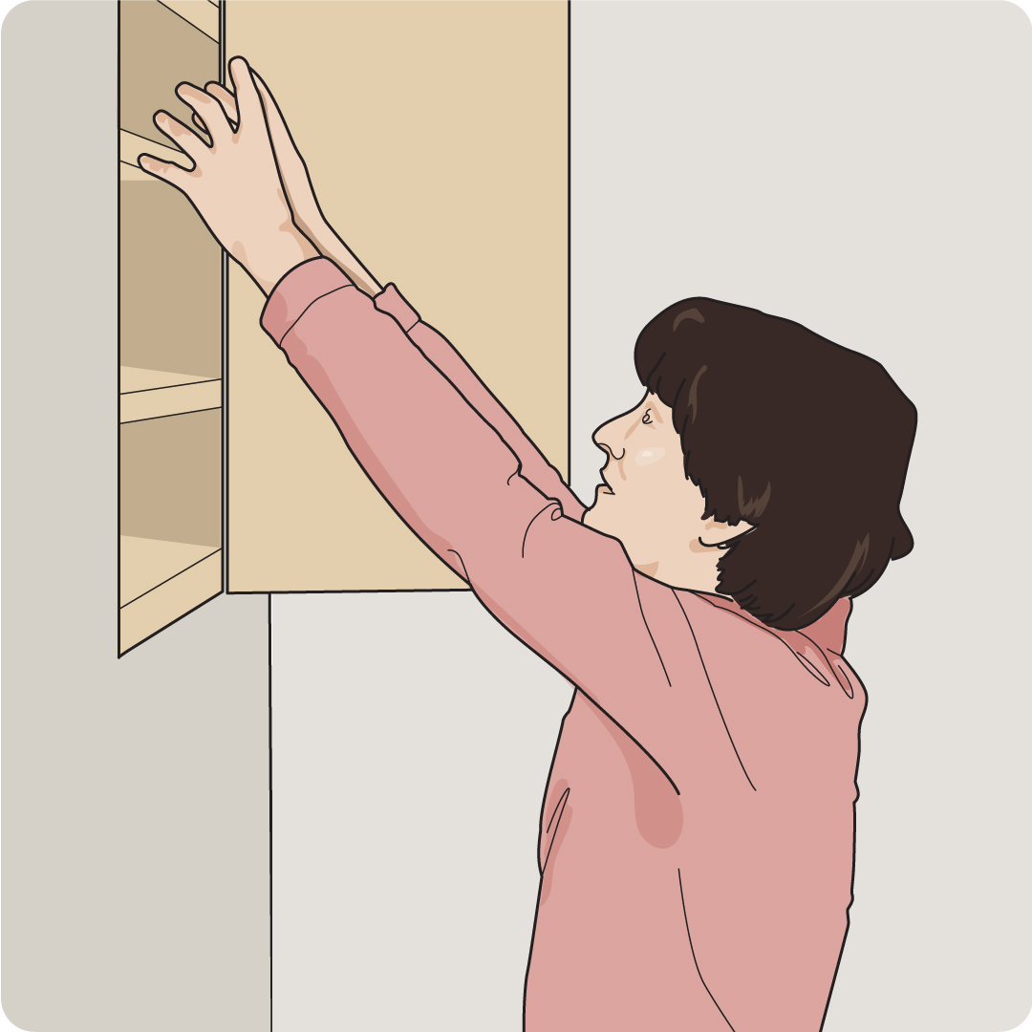
Hands between floor and knee height
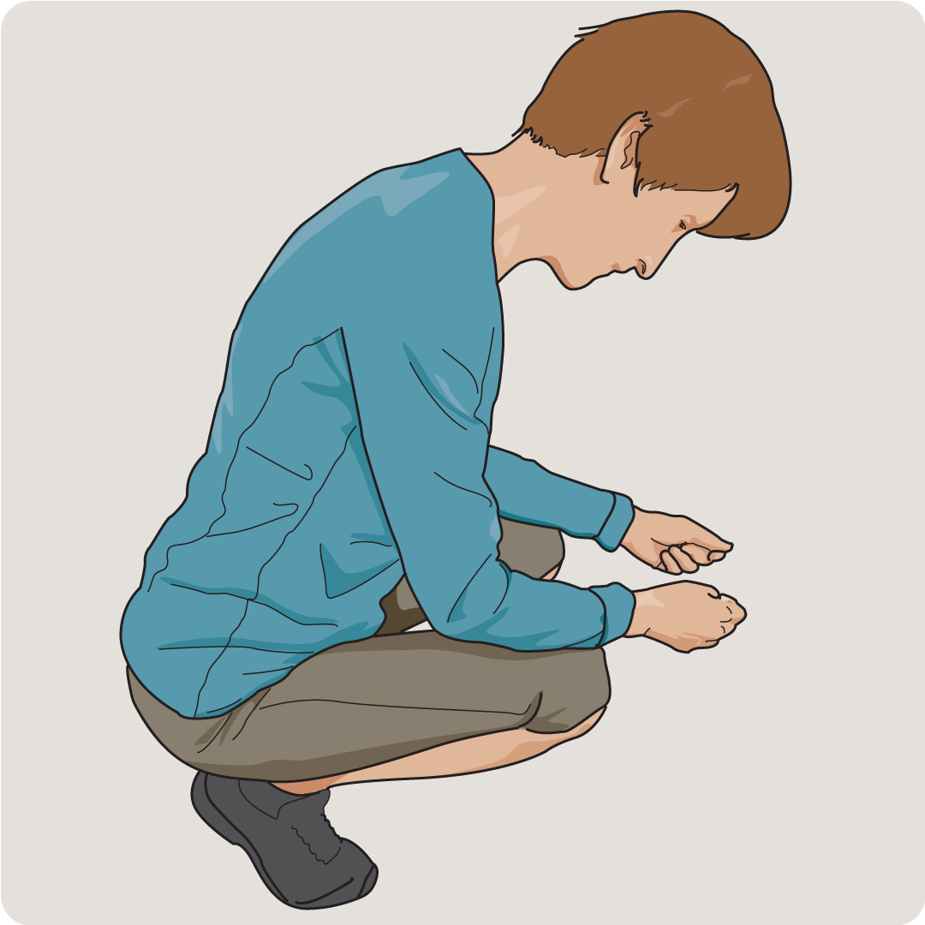

Question 23
Are one or both of your arms ever fully extended straight forward when you're doing the job, task, or work activity you're assessing today?
- Yes, my arms are frequently fully extended straight forward when doing a job, task, or work activity
- Yes, my arms are sometimes fully extended straight forward when doing a job, task, or work activity
- No, my arms are never fully extended straight forward when doing a job, task, or work activity

Question 24
When your arm(s) are outstretched, do you ever hold a tool or move an object?
- Yes, and it's often less than 5 lb / 2 kg
- Yes, and it's often 5 to 10 lb / 2 to 4.5 kg
- Yes, and it's often more than 10 lb / 4.5 kg
- No, I don't hold tools or objects when my arm(s) are outstretched

Question 25
Awkward Postures
How is your head positioned when you're doing the job, task, or work activity you're assessing today?
- It's often neutral (directly between shoulders; chin is level)
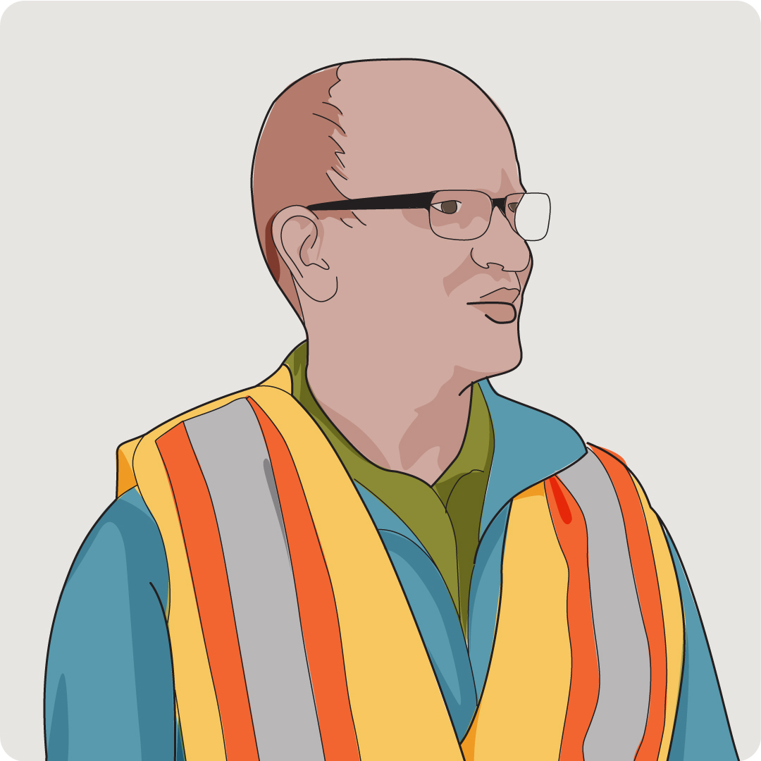
- It's often tilted up or down less than 15 degrees
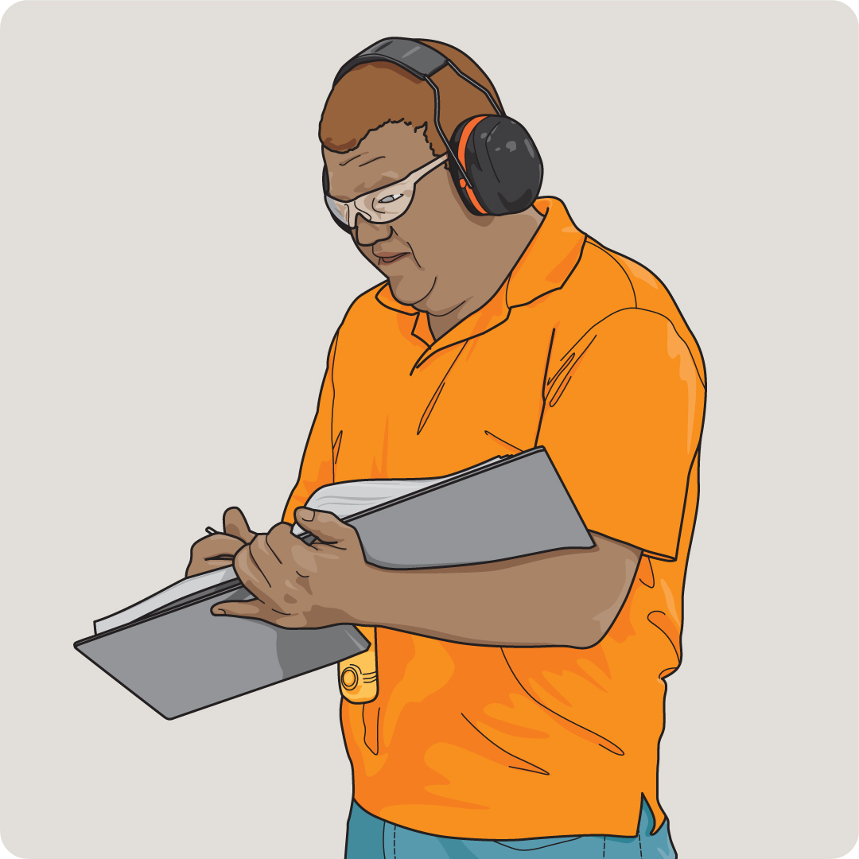
- It's often tilted up, down, or to the side more than 15 degrees
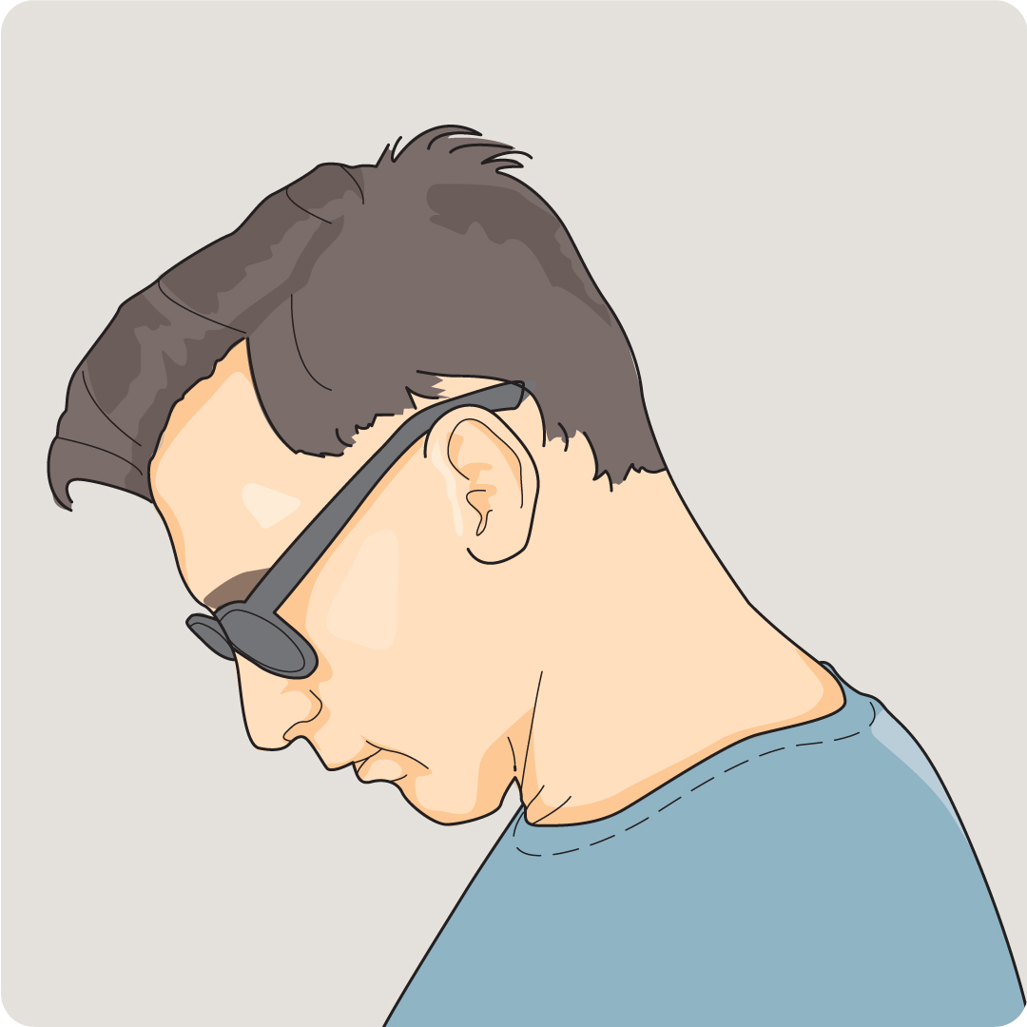

Question 26
How far do you typically bend your wrist up and down? Please use the image below as a reference.
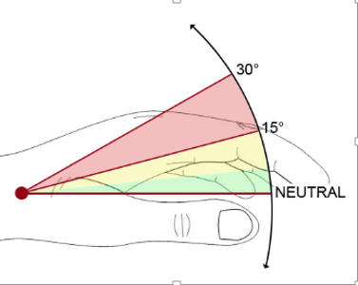
- Usually 0 to 14 degrees up or down
- Usually 15 to 30 degrees
- Usually more than 30 degrees

Question 27
How far are you angling your wrist from side to side?
- Usually 0 to 10 degrees left or right
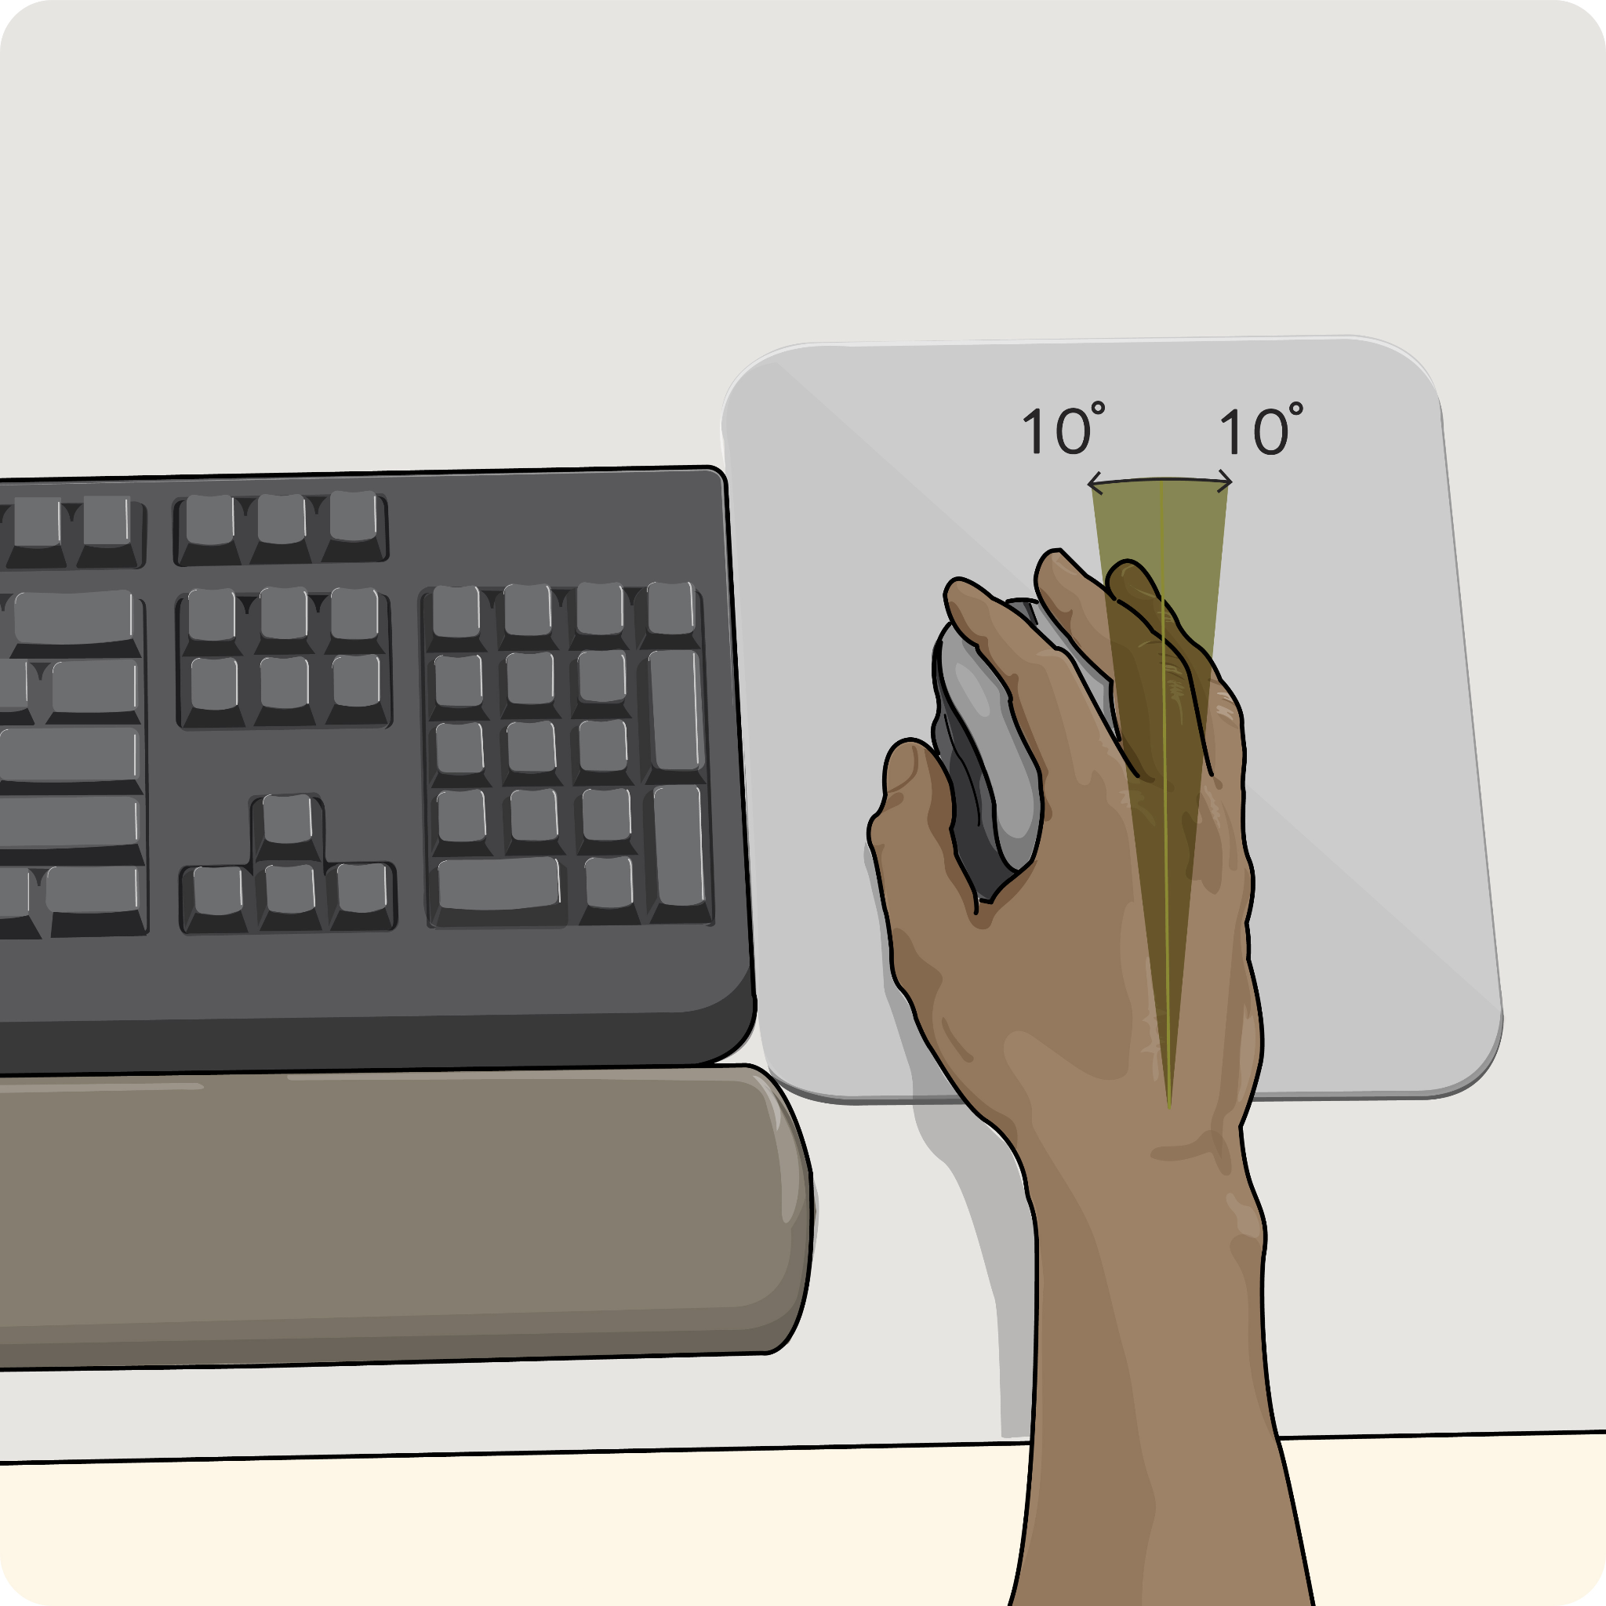
- Usually 10 to 20 degrees
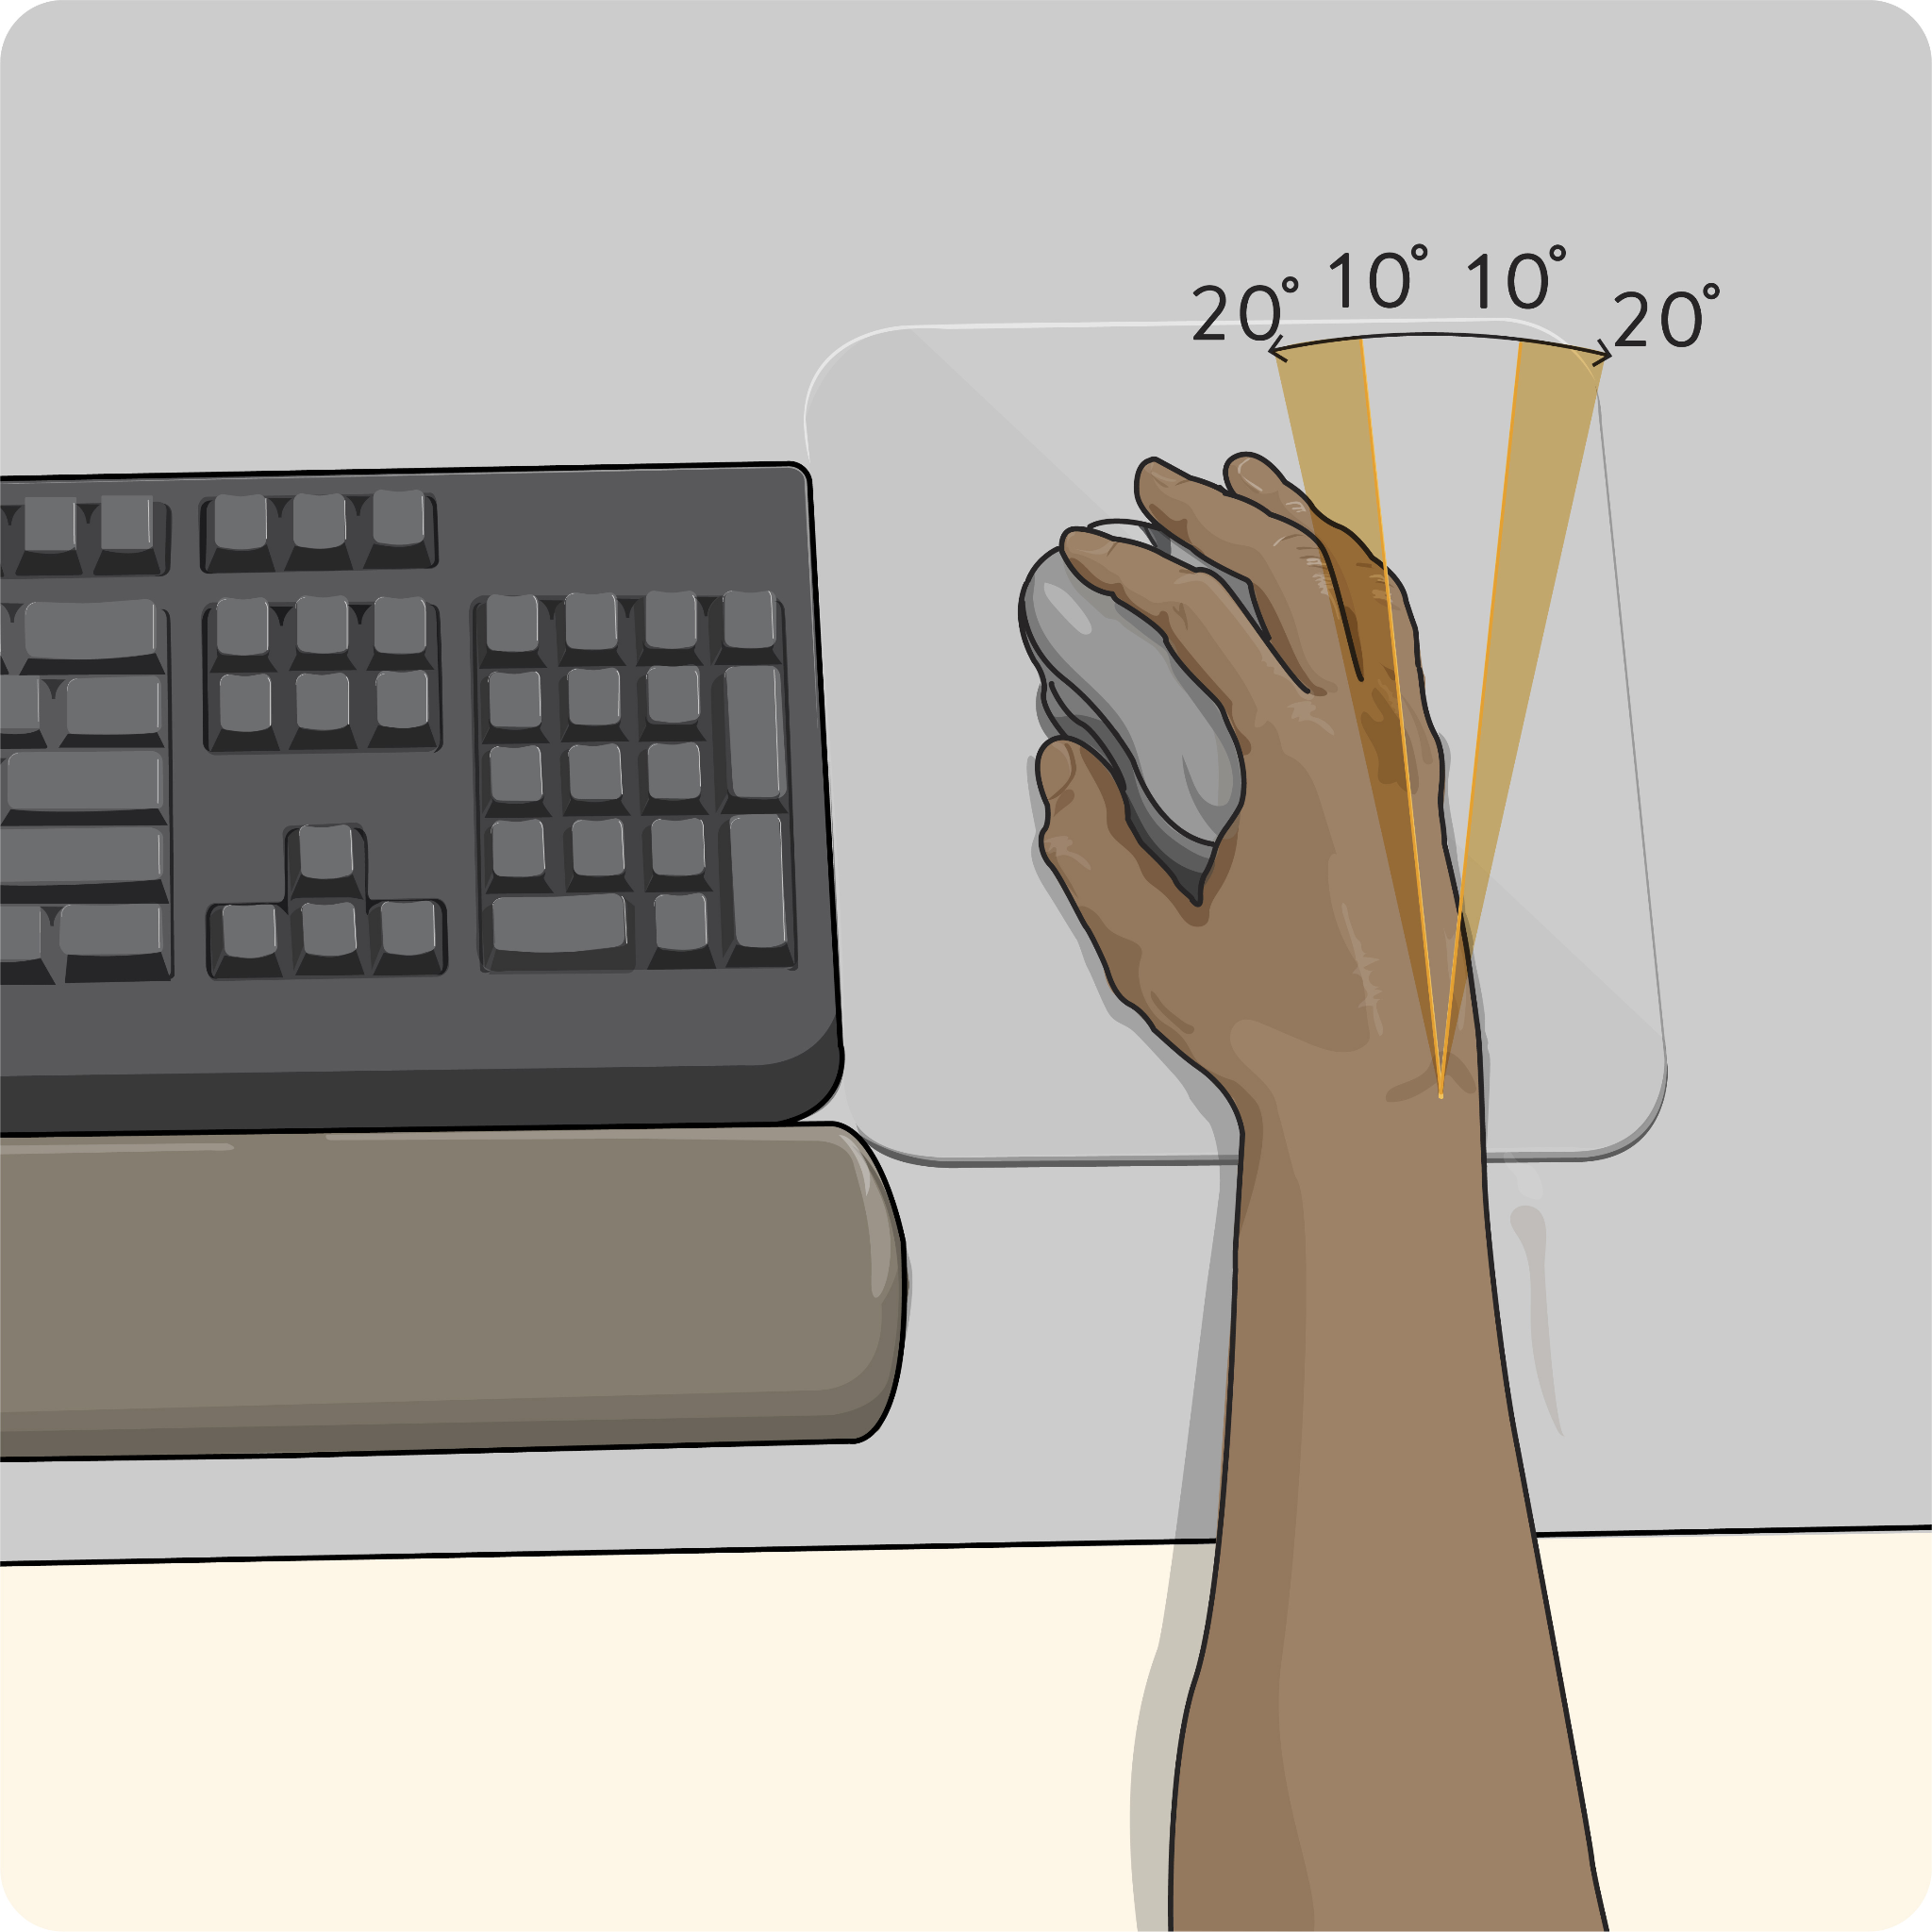
- Usually more than 20 degrees
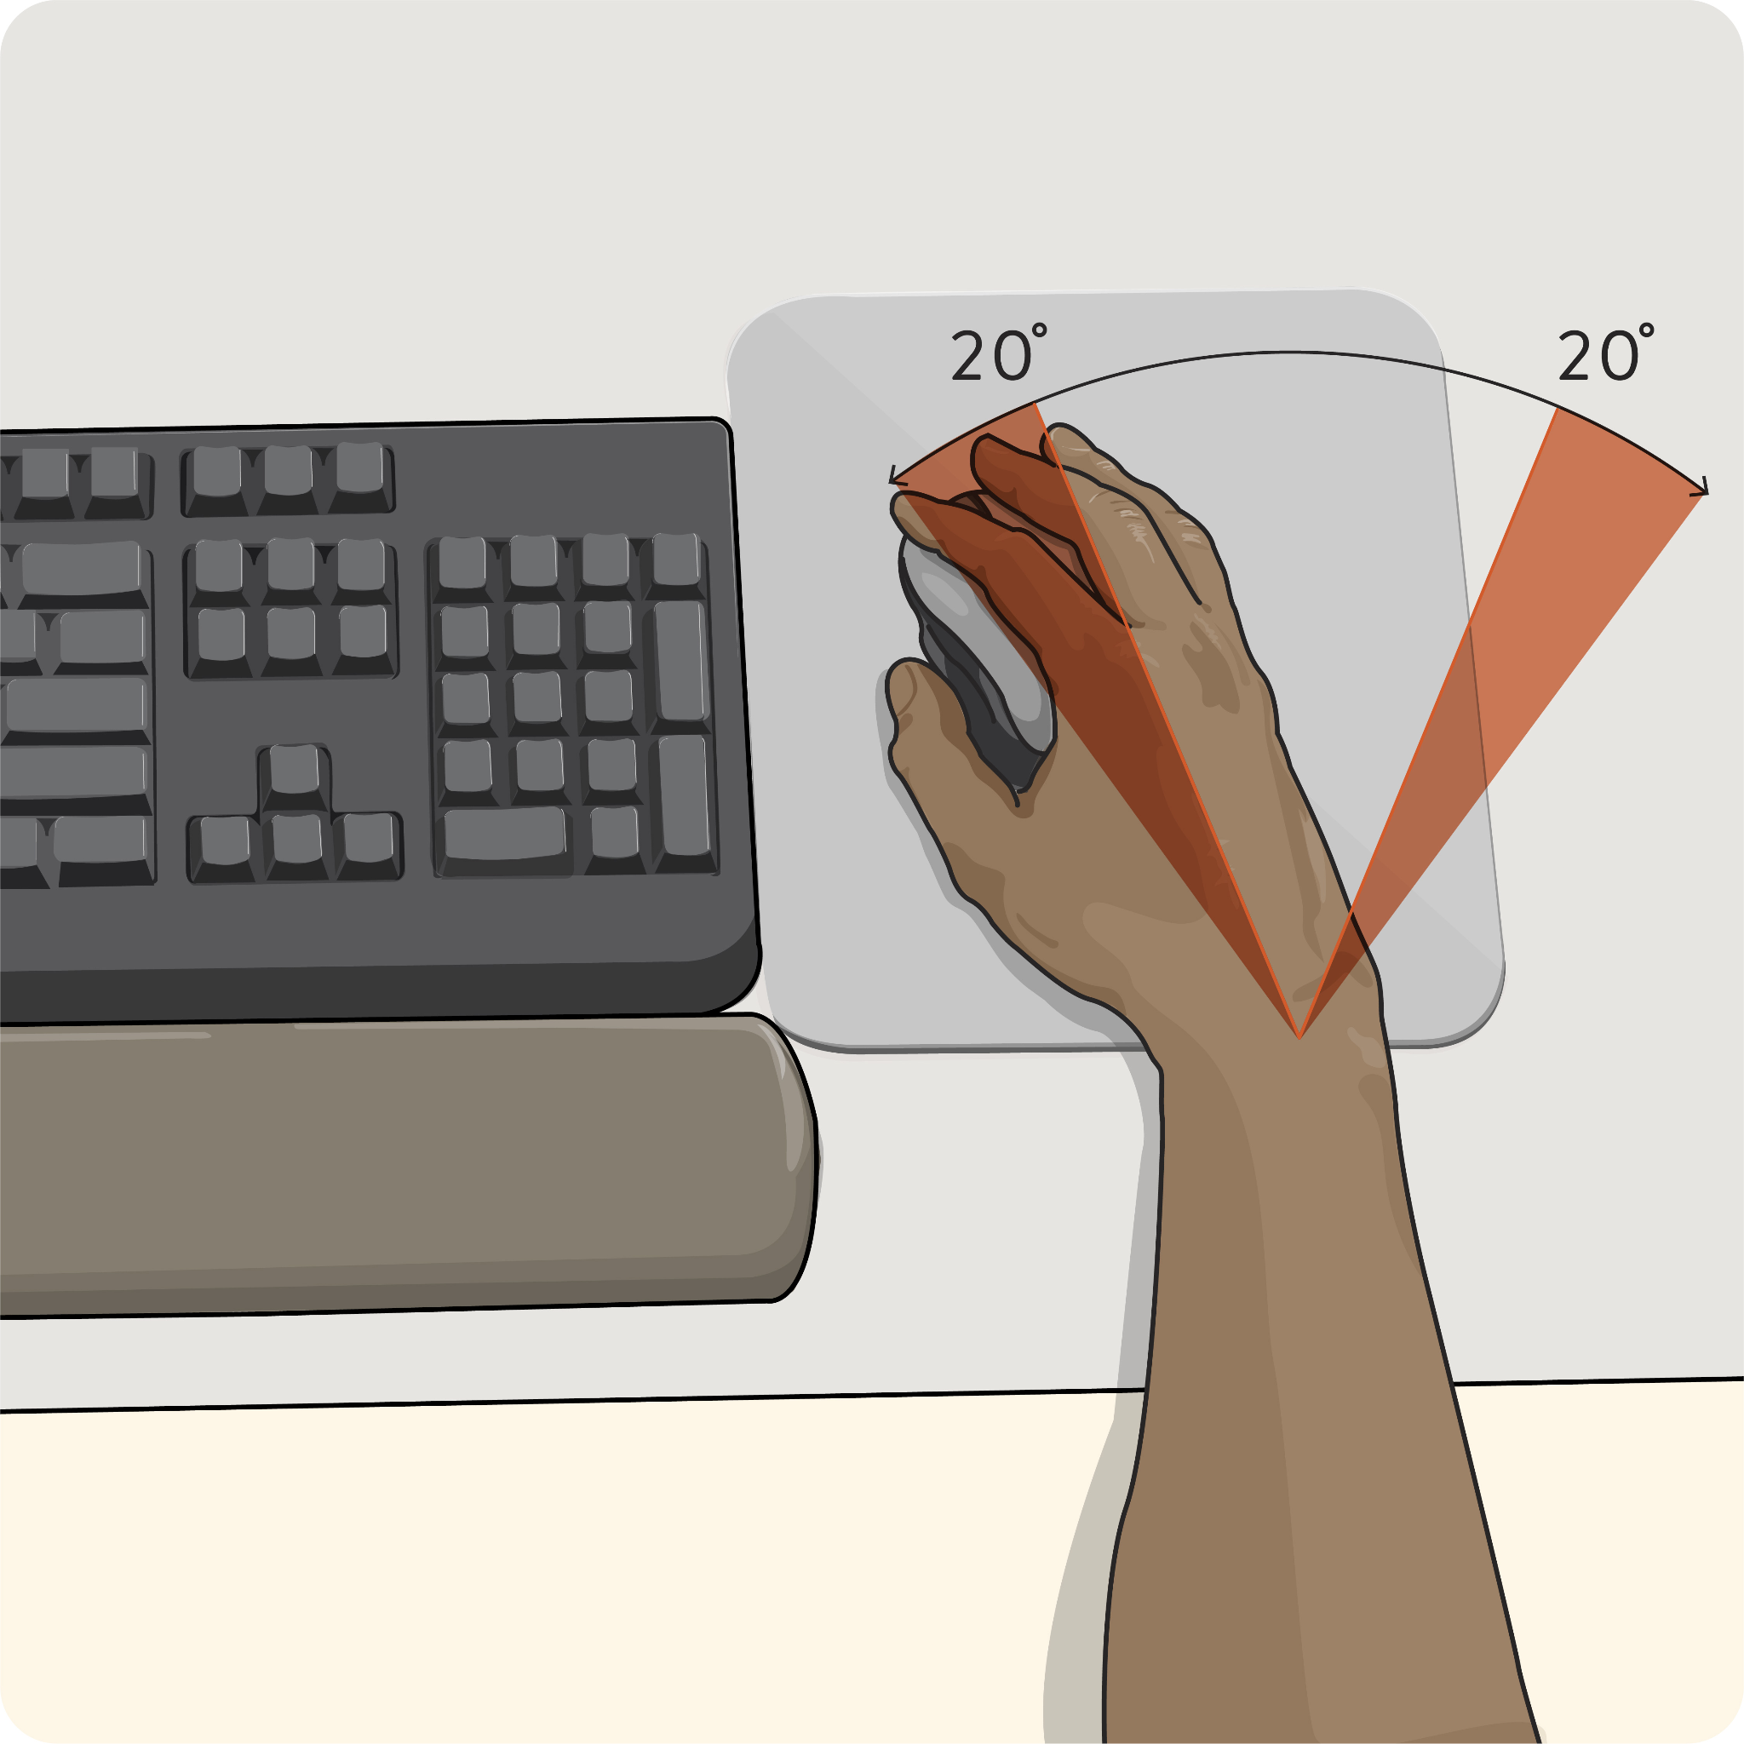

Question 28
Is it possible for you to keep all objects you need to push, pull, lift, use, etc. close to your body?
- Yes, frequently
- Yes, sometimes
- No, never

Repetitive Move
The next set of questions will help ErgoCheck identify movements you repeat frequently over a period of time (e.g., lifting many boxes onto a shelf or typing for most of a shift). Repetitive movements - particularly if they require some force or involve awkward postures - often cause discomfort.

Question 29
Think about a typical workday - or, if you're assessing a specific task or activity, the part of the workday when you're performing that task. How much time do you spend performing similar movements over and over?
- Less than 30 minutes a day
- 30 minutes to 2 hours a day
- 2 to 4 hours a day
- More than 4 hours a day

Question 30
How much time do you spend bending your wrist up or down more than 15 degrees? Please use the image below as a reference.
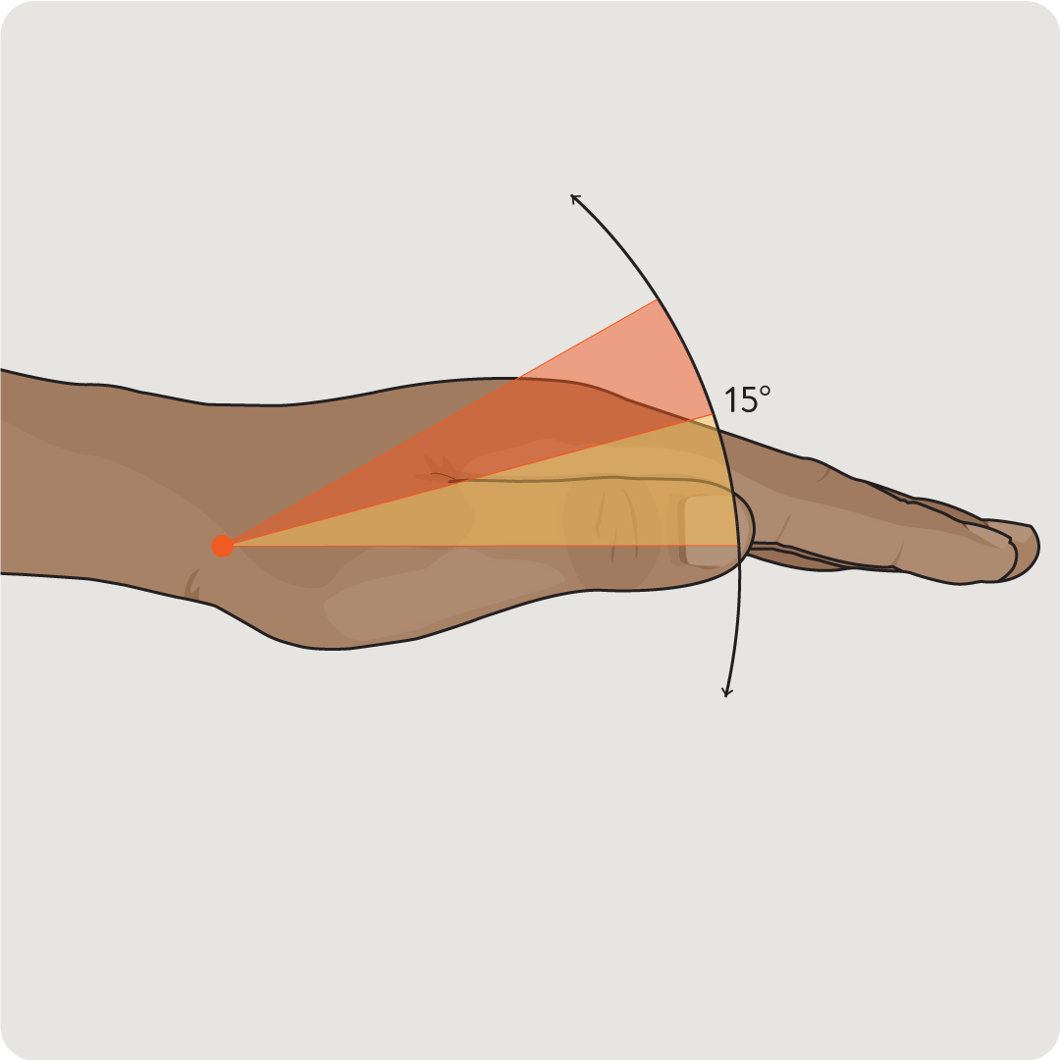
- Less than 1 hour a day
- 1 to 2 hours a day
- More than 2 hours a day
- No time at all

Question 31
How much time do you spend angling your wrist more than 15 degrees to the left or right? Please use the image below as a reference.

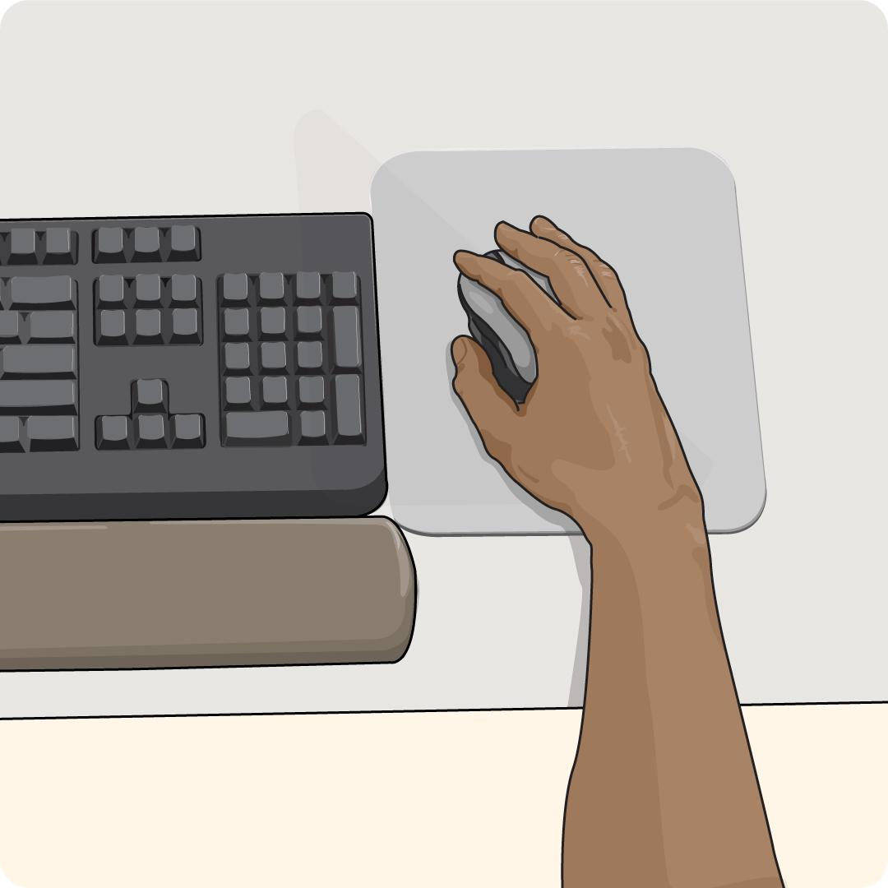
- Less than 1 hour a day
- 1 to 2 hours a day
- More than 2 hours a day
- No time at all
Question 32
How much time do you spend using forceful muscular exertions (more than 18 pounds / 8 kg with your own strength) when using a tool or handling an object?
- Less than 5 minutes a day
- 5 to 25 minutes a day
- 30 minutes to 2.5 hours a day
- 2.5 to 5.5 hours a day
- More than 5.5 hours a day
Question 33
When you grasp an object between your thumb and fingertips, it's called a pinch grip.

When you're doing the job, task, or work activity you're assessing today, how much time do you spend using a pinch grip to hold an object that's heavier than 2 pounds / 1 kg?

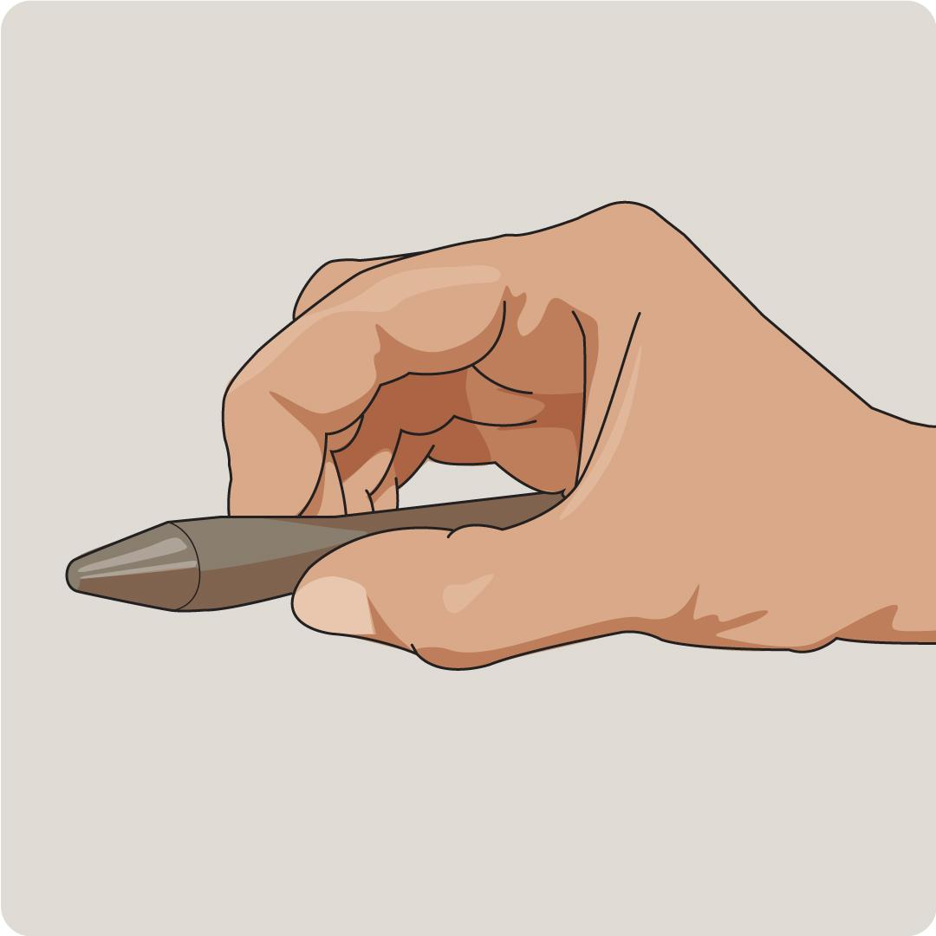
- Less than 2 hours a day
- More than 2 hours a day
- No time at all
Question 34
When you wrap your hand around an object to hold it, it's called a power grip.
How much time do you spend using a power grip to hold an object that's heavier than 10 pounds / 4.5 kg?
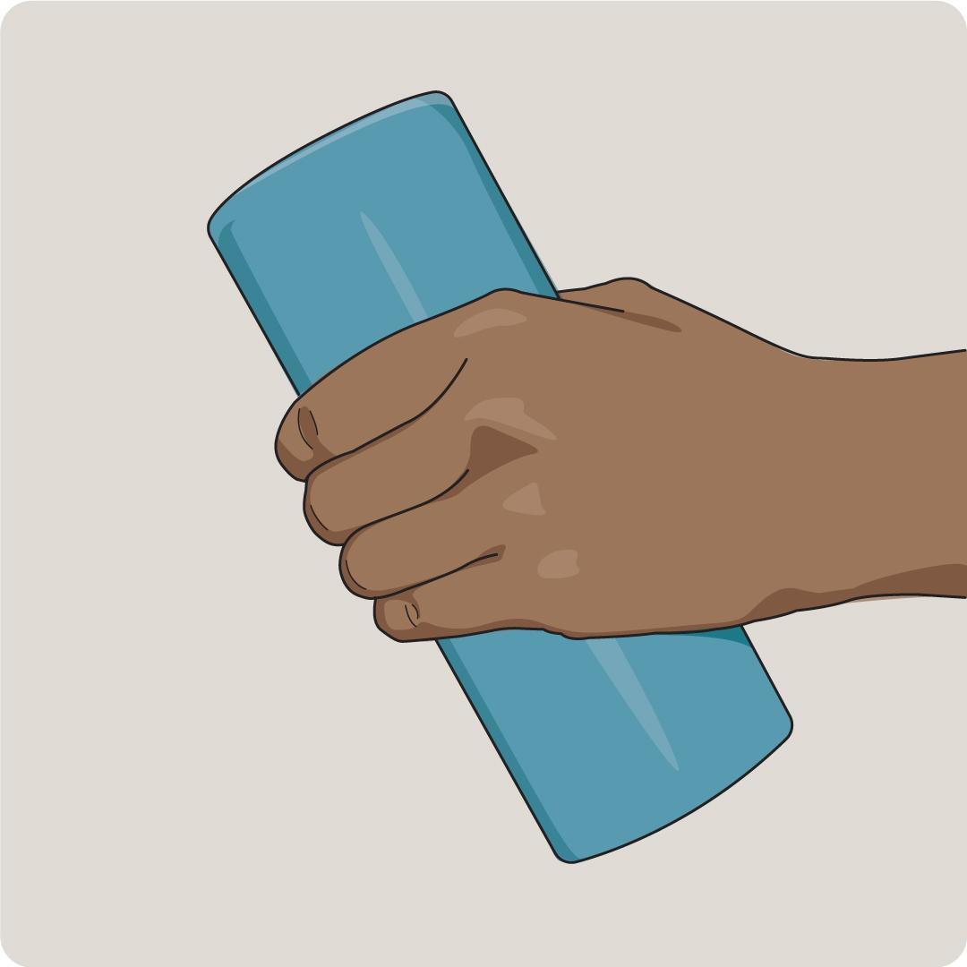
- Less than 2 hours a day
- More than 2 hours a day
- No time at all
Question 35
If you use tools or equipment that cause vibrations in part or all of your body, how much time do you spend using these tools?
- Less than 1 hour a day
- 1 to 4 hours a day
- More than 4 hours a day
- I don't use these types of tools or equipment
Question 36
If you push or pull any items that are heavier than 80 pounds / 36 kg, how much time do you spend moving these items over rough surfaces (like gravel, tile, or uneven ground) or soft surfaces (like sand, mud, or grass)?
- Less than 5 minutes a day
- 5 minutes to 1 hour a day
- More than 1 hour a day
- I don't move these types of items over rough or soft surfaces

Environmental Factors
The next set of questions will help ErgoCheck understand how your work environment may impact your risk of developing an MSI. Everything from noise, lighting, and temperature to frequent overtime and tight deadlines can impact your risk.

Question 37
Think about a typical workday - or, if you're assessing a specific task or activity, the part of the workday when you're performing that task. Are you ever distracted by noises (sirens, loud talking, traffic, etc.)?
- Frequently
- Sometimes
- No
Question 38
Are you affected by the sun shining or reflecting into your eyes (aka glare)?
- Frequently
- Sometimes
- Rarely
- Never
Question 39
If your work requires you to look at fine details or read small print, are you able to do this easily?
- Frequently
- Sometimes
- Rarely
- Never
- My work doesn’t require me to do this
Question 40
If you work in cold environments, do you feel discomfort in your arms, back, legs, fingers and/or toes?
- Yes
- No
- I don’t work in cold environments

Question 41
Considering your work requirements, how often are you asked to work overtime for one hour or longer?
- Frequently
- Sometimes
- Rarely
- Never

Question 42
How often are you asked to work to tight deadlines?
- Frequently
- Sometimes
- Rarely
- Never

